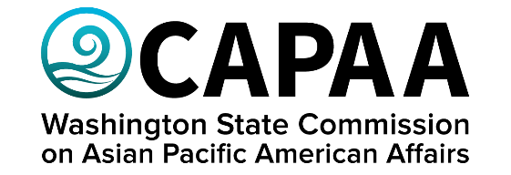

**Public Board Meeting Agenda**

Saturday, May 31, 2025 | 9:30 a.m. – 11:30 a.m.

Virtual via Zoom

Zoom: [Join Zoom Meeting](https://us02web.zoom.us/j/85456676041?pwd=SzDteCcgPjtpoNK4D4H94OWO0O6jMT.1) [Meeting ID: 854 5667 6041; Passcode: 729335]

|  |  |  |
| --- | --- | --- |
| **AGENDA** | | |
| **Time** | **Business Item** | **Speaker** |
| 9:30 | Call to Order | Chair Faitalia |
| 9:33 | Roll Call | Chair Faitalia |
| 9:35 | Approval of Agenda   * *Action to approve* | Chair Faitalia |
| 9:37 | Approval of Minutes   * *Action to approve* | Chair Faitalia |
| 9:40 | Public Comment |  |
| 9:50 | Staff Report | Director Nguyen |
| 10:00 | OCA Conference | Director Nguyen |
| 10:05 | Legislative/Budget Update | Project Manager Kamkar |
| 10:25 | Discussion on Sponsorship Requests   * Action Item | Director Nguyen |
| 10:30 | Commissioner Roundtable | Roundtable |
| 10:45 | Meet Kabul Seattle Community Services | Executive Director Dawood Niazi & Hadi Abdulhai |
| 11:00 | Presentation by the Office of Regulatory Innovation & Assistance | Hugo Nicholas, Small Business Consultant |
| 11:20 | Adjournment | Chair Faitalia |